File System
High Level Design Specification

DMT/AD03/TMP

Project Code
Project Name | File System

Prepared/Modified by | Role | Date of Preparation
Swapnil Kadam | Team Leader | 04/01/2014
Reviewed by | Role | Date of Review
Mariah Fernandes | CM | 08-01-14
Approved by | Role | Date of Approval
Circulation List |  | Version Number of the template:1.0
Version Number | 1.4

TABLE OF CONTENTS

1. Objective 3
2. Alternate Design 4
3. System Architecture 5
4. Design Consideration & Trade Offs 12
5. Representative Use Cases 13
6. Activity Diagrams 17
7. Interface Design 22
7.1 User Interface Design 22
7.2 Internal And External Interface Design 24
8. Test Design 24
9. Supplementary Design Aspects 25
9.1 Logging 25
9.2 Data Persistence 25
10. Future Scope 26
REVISION HISTORY OF THE WORK PRODUCT 27

Objective

The purpose of this project is to develop File system. File system provides layer of abstraction so that programs do not have direct access to raw disk. File system are data structures that manages files-FAT table. File system contain following modules.

      - Initialization
      - File system Operations
      - Memory Handler
      - Data management
      - Error Handler

File system provides facilities for accessing, organizing and further managing the data.
The application could be developed by IIDM Methodology which is a part of Software Development Lifecycle.

File system provides for a login menu wherein user is allowed to login as admin or user.
If user selects admin login, system asks the user to enter password to verify admin authenticity. If admin is successfully authenticated, admin is allowed to perform various operations like creating the root file, adding users to the system and viewing the error log.

If user selects user login, system redirects user to the general working of the file system. Here, user is allowed to perform several operations like creating a file, deleting a file, modifying a file, listing all files present in the root file as well as viewing the contents of a specific file.

Alternate Design
There are multiple design plans for developing File System which includes:
- C++ using File Handling
- Unix
- C
- C++ Implementation:
Implementation using C++ includes use of Object Orientation Programming concepts where multiple classes can be created having communicating objects within them and file handling concept is also used for creating and performing related operations as mentioned in file system requirement specification.
- UNIX Implementation:
Implementation using UNIX includes use of UNIX commands for creating and performing File related operations.
- C Implementation:
Implementation using C includes use of Structure concepts for keeping all logically related information in single unit and file handling concept is also use for creating and performing related operations as mentioned in file system requirement specification.

Rational for choosing the current design as C Programming Language:
  - Portability:
    - C Programs are portable i.e. they can be run on any Compiler with little or no modification Compiler and Preprocessor make it possible for a C Program to be run on different PC.
  - Bit Manipulation:
    - C Programs can be manipulated using bits. We can perform different operations at bit level. We can manage memory representation at bit level.
  - High Level Features:
    - It is more user friendly as compared to previous languages.
  - Modular Programming:
    - C program consist of different modules that are integrated together to form complete program.
  - Efficient Use of Pointers: A pointer has direct access to memory.

System Architecture

- The size of File system is 10MB.
- The File system is further partitioned in to 4KB blocks each where contents of file to be stored.
- FAT table information and the data blocks are also added to each data block for accessing file related additional information.
- Initially all loading operations are performed which will create linked list from the file system.
- All the operations on the files will be performed in linked list and at exit condition the entire linked list is written to file system.
- FAT table contains the information about the files. The first data block is FAT table .The remaining data blocks are files which contains index number of file along with contents of file and delimiter.

File System
Hard Disk File System
File System
FAT Table
Data Block: File 1
Data Block: File 2
Data Block: File 3
Data Block: File 4
.
.
Data Block: File 2546

2.1 Software Architecture

- File System Initialization.
- Creation of files within file system.
- List the files stored in the file system.
- Display specific file.
- Delete files from the file system.
- Modify file.

- Create Root File in File System:

- Creating Root file of 10MB Size.

Algorithm:
Step 1: Run the exe code.
Step 2: If file system does not exists then jump to step 4.
Step 3: If file system exists then jump to step 9.
Step 4: Create File system.
Step 5: Create FAT table.
Step 6: Create data block partition.
Step 7: Copy FAT table to the file system.
Step 8: Copy data block to the file system.
Step 9: Load FAT table and data Block.
Step 9: Display list of available options.
Step 10: Exit.

1. Create File in File System:

- Creating Data Blocks of Fixed Size.

Algorithm:
Step 1: Enter the file name to be created.
Step 2: If maximum capacity of root file exceeds 10MB then jump to step 12.
Step 3: If the file name is not entered then jumps to step 11.
Step 4: If file name size exceeds 255 characters jump to step 14.
Step 5: If the entered file name already exists in file system then jump to step 13.
Step 6: If file does not exist, then enter contents of the file (maximum 10 MB).
Step 7: Put contents in temporary file.
Step 8: If data block size exceeds 4KB then create new data block and put data inside the new block.
Step 9: Add timestamp information of file to File System.
Step 10: Copy contents of Temporary file into File System.
Step 11: Show error message saying “The File Name Not Entered..!!” and jump to step 15.
Step 12: Show error message saying “Maximum File Limit is Reached..!! Cannot Create More Files..” and list in Log file and jump to step 15.
Step 13: Show error message saying “File Already Exist..!! And jump to step 15.
Step 14: Show error message saying “The File Name Exceeds the Limit..!!” and jump to step 15.
Step 15: Ask user to continue or not
Step 16: If user wants to continue then jump to step 1.
Step 17: Exit.

- List all Files from File System:

- Display the list of all the files.

Algorithm:

Step 1: Open File System.
Step 2: If File System is empty then jump to step 4.
Step 3: Print following file details:
1. File name
2. File size
3. Access Mode
4. Created On.
5. Modified On.
6. Starting Data Block.
7. Number of Data Blocks and jump to step 5.
Step 4: Show error message saying “No File Exist in the System..!!”.
Step 5: Exit.

- Display Specific File from File System:

- If Filename is present display the file contents else display the error and exit.

Algorithm:
Step 1: Enter the file name to display the contents.
Step 2: If file doesn’t exists then jump to step 5.
Step 3: If file doesn’t have any content then jump to step 6.
Step 4: Display the file contents and jump to step 7.
Step 5: Show error message saying “File Does Not Exist...!!”
Step 6: Show error message saying “No Data Found in the Given File..!!”
Step 7: Exit.

4. Delete File from File System:

- If Filename is present and is in read-write mode, delete the file and its contents else display the error and exit.

Algorithm:
Step 1: Enter the file name to be deleted.
Step 2: If file doesn’t exists in File System then jump to step 6.
Step 2: If file have only read only access then jump to step 7.
Step 3: If file exists in File System then ask for confirmation.
Step 4: If user doesn’t want to delete then jump to step 8.
Step 5: Delete the specified file and jump to step 8.
Step 6: Show error message saying “File Does Not Exist...!!”.
Step 7: Show error message saying “File Cannot be Deleted as it is Read Only File..!!” and list in Log file.
Step 8: Exit.

5. Modify File from File System:

- If Filename is present and is in read-write mode, update the file and its contents else display the error and exit.

Algorithm:
Step 1: Display options
- Rename file
- Change file content
- Change access mode.
- Go back
Step 2: If Option is 1 then enter the file name to be renamed and jump to step 6.
Step 3: If Option is 2 then enter the file name to be modified and jump to step 10.
Step 4: If Option is 3 then enter the file name to be change the access permission and jump to
step 20.
Step 5: If Option is 4 then jump to step 7.
Step 6: If entered file name does not exists then jump to step 23.
Step 7: Enter name of file to be renamed.
Step 8: If file have only read only access then jump to step 22.
Step 9: Rename the file name to new name and jump to step 24.
Step 10: Display options
- Append
- Overwrite
- Go back.
Step 11: For Option is 1
Step 12: If entered file name does not exist then jump to step 23.
Step 13: If file has only read only access then jump to step 22.
Step 14: Enter the content to be appended and jump to step 24.
Step 15: For Option is 2
Step 16: If entered file name does not exists then jump to step 23.
Step 17: If file has read only access then jump to step 22.
Step 18: Enter the content to be overwritten and jump to step 24.
Step 19: For Option 3 jump to step 1.
Step 20: If entered file name does not exists then jump to step 23.
Step 21: Take access mode from the user and change the file mode and jump to step 24.
Step 22: Show error message saying “Read Only File..!!.Cannot Change the Name..!!” and list in Log file.
Step 23: Show error message saying “File Does Not Exist..!!”.
Step 24: Exit.

6. Display Error Log file:

- If error occurs during execution then display the list of errors occurred in a file.

Algorithm:
Step 1: Read the contents present in the error log file.
Step 2: If error log file is empty then jump to step 3.
Step 2: Display error information present in error log file and jump to step 4.
Step 3: Show error message saying “Error Log File Is Empty..!!”.
Step 4: Exit.

Design Consideration & Trade Offs

Design Considerations:

- File System is implemented using C-Programming language.
- C gives you better control over what happens when your code is executed as functions which are present for performing necessary operations are called by the driver module as and when user specifies own choice.
- C supports variable sized arrays which are implemented using linked list, also termed as Dynamic allocation of memory.
- C requires less runtime support.
- Makes it more suitable for low-level environments such as embedded systems or OS components.

Tradeoffs:

- A linked list is used for storing all File related information such as File name, File mode, index number etc which is copied into file.
- Maximum number of files can be opened at a time concept is not implemented due to time constraints.
- Data corrupt scenario is also not implemented due to time constraints.

Representative Use Cases

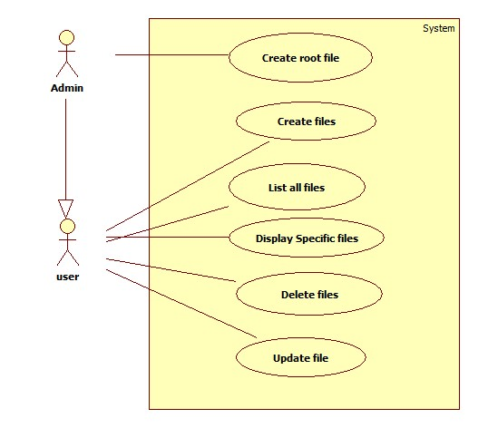
Level 0 Use case: File System

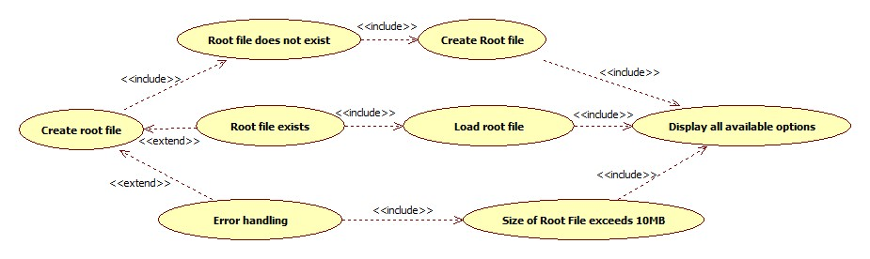
Level 1 Use case: Create Root File

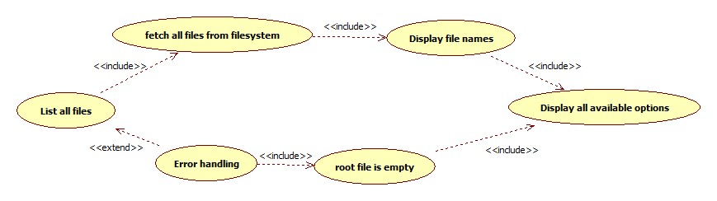
Level 1 Use case: List all Files

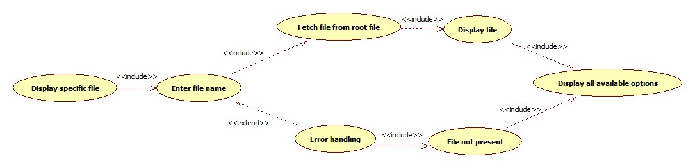
Level 1 Use case: Display specific File

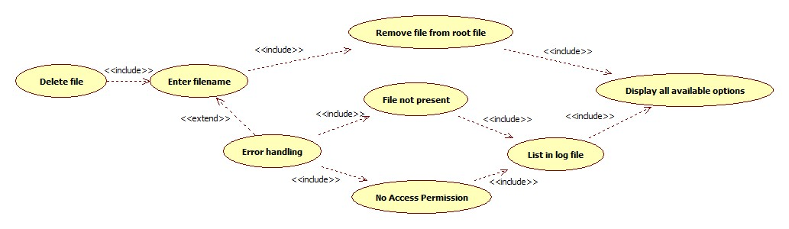
Level 1 Use case: Delete File

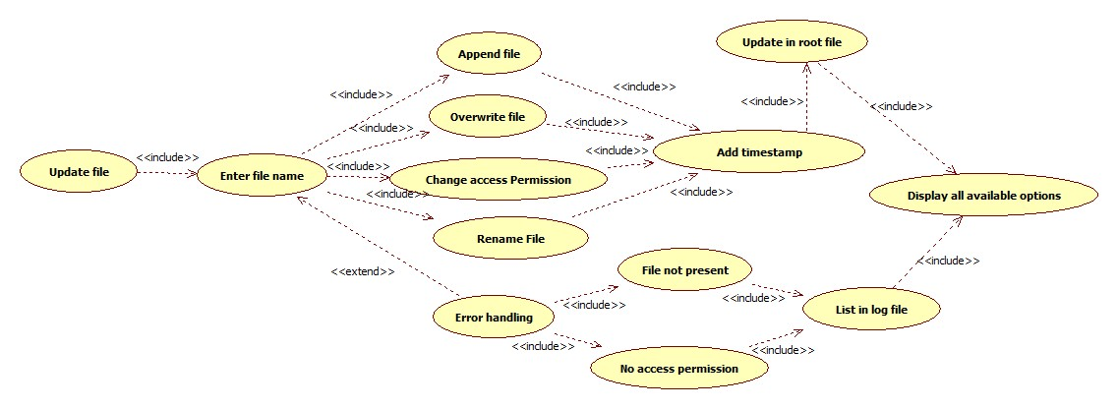

Level 1 Use case: Update file

Activity Diagrams
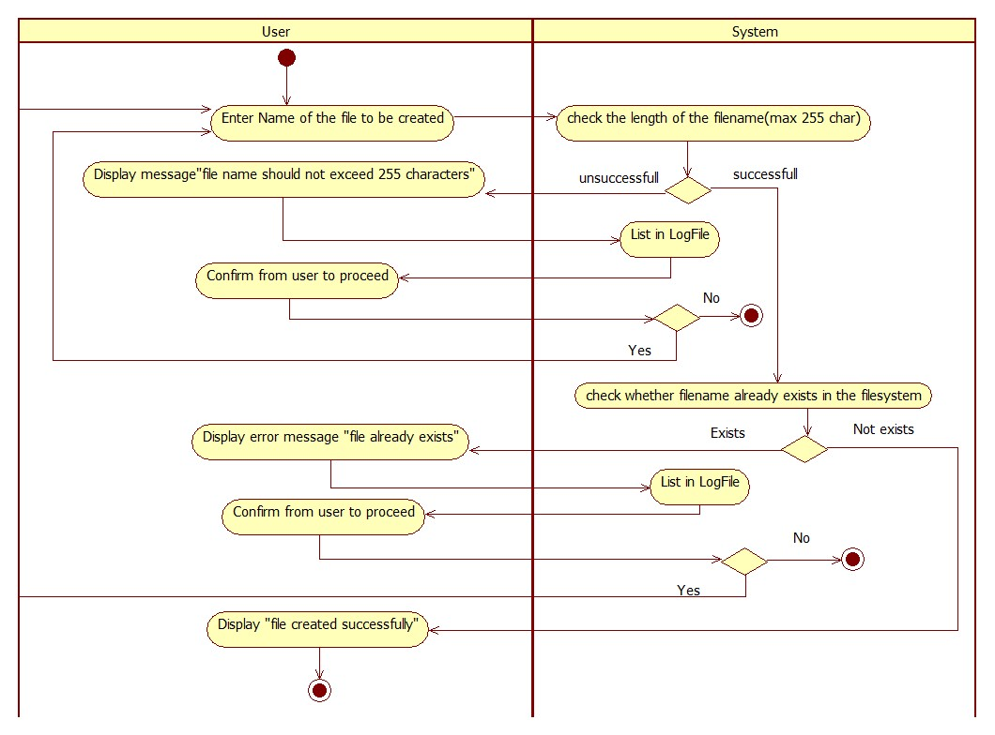
Create file in File System

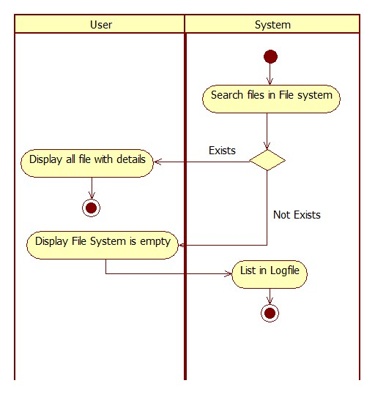
List all files from File System

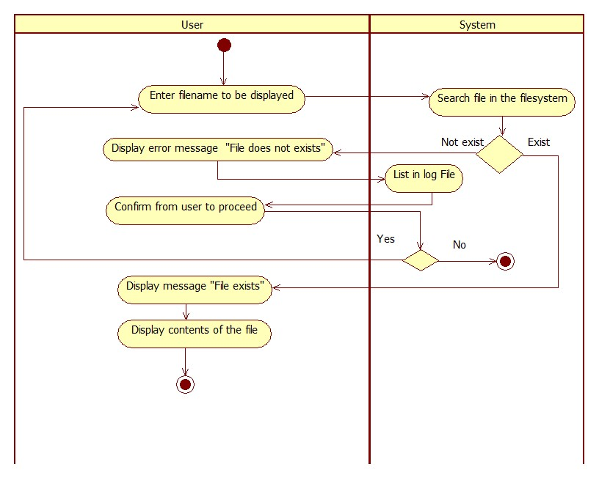
Display specific file from File System

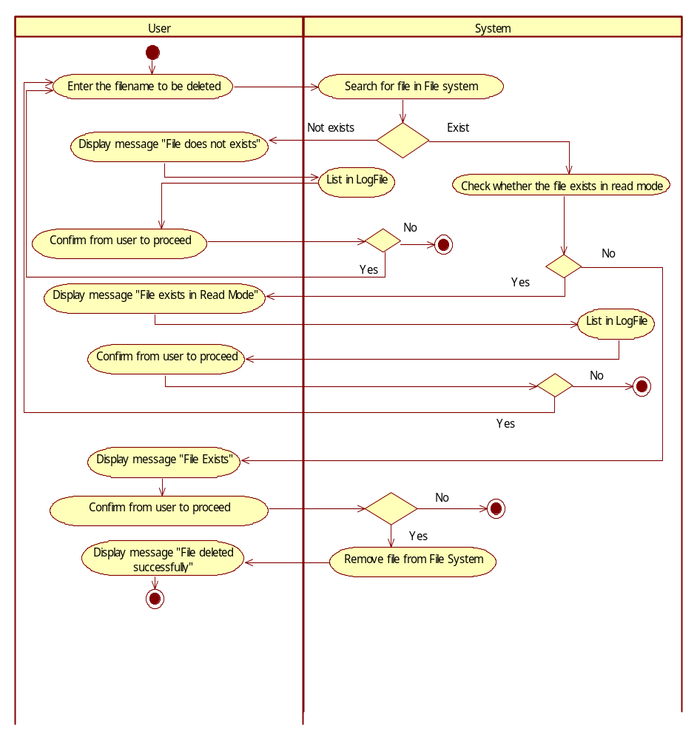
Delete file from File System

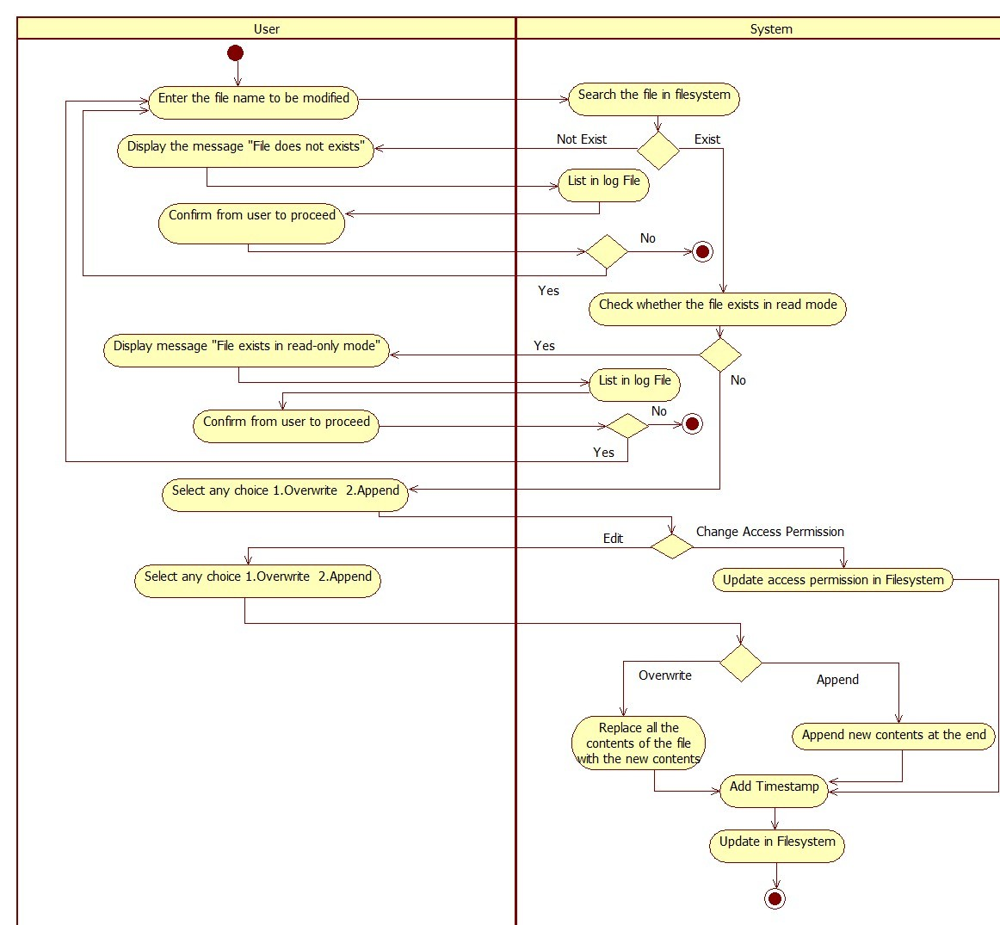
Update file from File Sysytem

Interface Design

User Interface Design

Inputs:
The input media that we use in the file system is keyboard. The input to the file system includes the acceptance of the file name which will be used for performing multiple operations i.e. Creating file, Display Specific file. Change access Permission etc.

Outputs:
The output media is the monitor. The output from the file system includes
  - The successful creation of file.
  - The successful modification of file.
  - Displaying the content of current file successfully.
  - The successful listing of all files.
  - The successful deletion of file.

Error Messages:
- File name already exists in file system.
- Root file already exists.
- File not present in File system.

Internal And External Interface Design

Interface Description:

User interface is provided by command prompt as the application is developed as console application.
Basic user input device is Keyboard and output device is Monitor.

Purpose:

Purpose of user interface is to take inputs such as file name which is to be created, deleted, and displayed.
Output device is use to display the operations which are performed on file system.

Interface Type:

There is only one common interface for the application i.e. command prompt which provides way to interact with the application.

Modules:

There is only one driver module which is used to connect to all the unit modules for performing respected operations.

There are multiple modules as mentioned below:

      - Initialization
      - File system Operations
      - Memory Handler
      - Data management
      - Error Handler

Test Design

Please refer:

- Low Level Design and Unit Test Plan

Supplementary Design Aspects

Logging

Log file is kept for collecting all the errors/exceptions which will be stored in error log file. Necessary validating functions are also embedded which will restrict user for providing appropriate information.

Data Persistence

Data Structure is used i.e. Linked list for implementing File system which contains all information related to file and same information is stored in 10MB Root file which will provide better data persistence.

Future scope

File system can be further improved for adding additional functionality and can be extended in order to provide better functionality.

- File system can be restricted for not allowing access to the files of other user to perform any operations on them.
- File system can also be implemented for users who have created a file such that the file can be deleted or modified by that user only by setting the access permission to Read mode.
- Creation of file by that particular user with details can also be implemented.
- Extending size of file system can also be done.
- Size of data blocks can also be increased for allowing large data to be stored in one block.
- Handling holes created in memory due to deletion of a file so that it doesn't overwrite contents of a file in the next memory block
REVISION HISTORY OF THE WORK PRODUCT
<to be maintained by projects>

# | Date | Version # | Section Changed | Details of changes made | Approved By
1 | 03-01-2014 | 1.0 | Document Created | Document Created
2 | 06-01-2014 | 1.1 | Use case Diagrams/Addition of Activity Diagram | Diagram flow was incorrect
3 | 07-01-2014 | 1.2 | Addition of content to Algorithm | Rename and Error log part added in algorithm part
4 | 08-01-2014 | 1.3 | Use case diagram  Description of the unit | Addition of alternate flows  Addition of login menu

